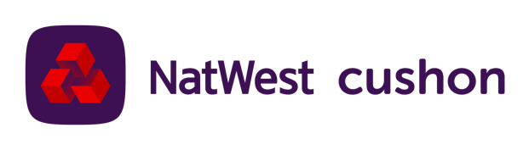
Our brand new NatWest Cushon Pension and savings provider
After a review of the market we’re delighted to be introducing NatWest Cushon, a holistic workplace savings platform that allows you to manage your pensions and other savings and investments all in a single place.
This means that from #DATE# you will have a new workplace pension provider as well as access to a wider range of saving and investment options to help you save for different life goals, such as saving for a deposit on your first home, saving for your children’s future or that holiday you’ve dreamed of.
As part of their offering NatWest Cushon have built a powerful app to help you get the best outcomes, whatever your saving goals, from getting on the property ladder through to getting ready for retirement.
Why NatWest Cushon?
NatWest Cushon offers a total workplace savings solution – not just pensions which means not only can you save for the retirement you deserve whilst doing better for the planet, but you can also save for all those events that happen before, like getting on the housing ladder.
Everything is on a mobile App. You can manage your pension and other savings all through NatWest Cushon’s market leading App, no need for paper.
What happens from #DATE#?
From #DATE#, pension contributions to #OLDPROVIDER# will cease and all future contributions will be paid into your new NatWest Cushon pension.
You will receive a welcome pack from NatWest Cushon and a new joiner notice enrolling you into the new pension. At this point, you will be asked to download the Cushon App which we would encourage you to do so that you can enjoy the best member experience.
You can choose to leave your existing pension pot with #OLDPROVIDER# where it is, or you can choose to transfer it to NatWest Cushon.
You will be able to take out an ISA from NatWest Cushon’s range of ISAs and save into it directly through direct debit.
And the last point
We want to make sure that you get the best value possible from the pension contributions you and the company pay. Moving to NatWest Cushon gives you the opportunity to engage more with your pension and in engaging more, you are more likely to make better decisions and get the retirement you deserve.

